Infinite Series Practice
- Determine whether the series converges or diverges. If the series converges, find the sum.
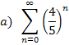

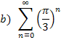

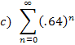

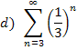

- Express the following as a ratio of integers.

- Determine whether the series converges or diverges. If it converges, find its sum.
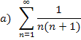

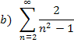

- Determine whether the series converges or diverges.
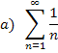

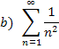

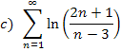
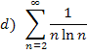

- Test the series for convergence or divergence.
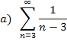

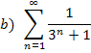

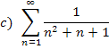

- Determine whether the series converges or diverges.
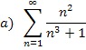

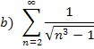

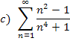

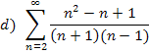

- Determine whether the series converges or diverges.
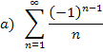

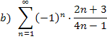

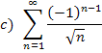

- Test the series for absolute convergence.

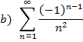

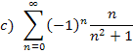

- Test the series for convergence or divergence.
